**DAILY ONLINE ACTIVITIES SUMMARY**

|  |  |  |  |  |  |  |  |  |
| --- | --- | --- | --- | --- | --- | --- | --- | --- |
| **Date:** | **29/05/2020** | | | | | **Name:** | **Albin Francis** | |
| **Sem & Sec** | **8th sem,A** | | | | | **USN:** | **4AL16CS008** | |
| **Online Test Summary** | | | | | | | | |
| **Subject** | | **BDA** | | | | | | |
| **Max. Marks** | | **30** | | **Score** | | | **20** | |
| **Certification Course Summary** | | | | | | | | |
| **Course** | **PYTHON FOR DATA SCIENCE** | | | | | | | |
| **Certificate Provider** | | | **Cognitive class.ai** | | **Duration** | | | **3.5hr** |
| **Coding Challenges** | | | | | | | | |
| **Problem Statement: Armstrong number is a number that is equal to the sum of cubes of its digits.** | | | | | | | | |
| **Status: Solved** | | | | | | | | |
| **Uploaded the report in Github** | | | | | **Yes** | | | |
| **If yes Repository name** | | | | | **albinfrancis008** | | | |
| **Uploaded the report in slack** | | | | | **Yes** | | | |

Online Test Details: (Attach the snapshot and briefly write the report for the same)

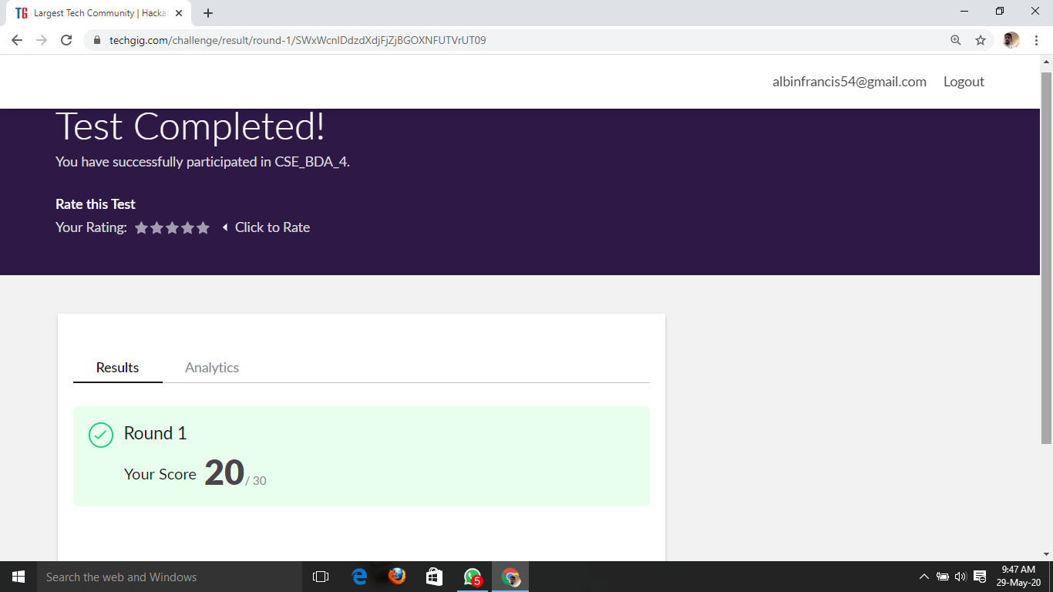

Certification Course Details: (Attach the snapshot and briefly write the report for the same)

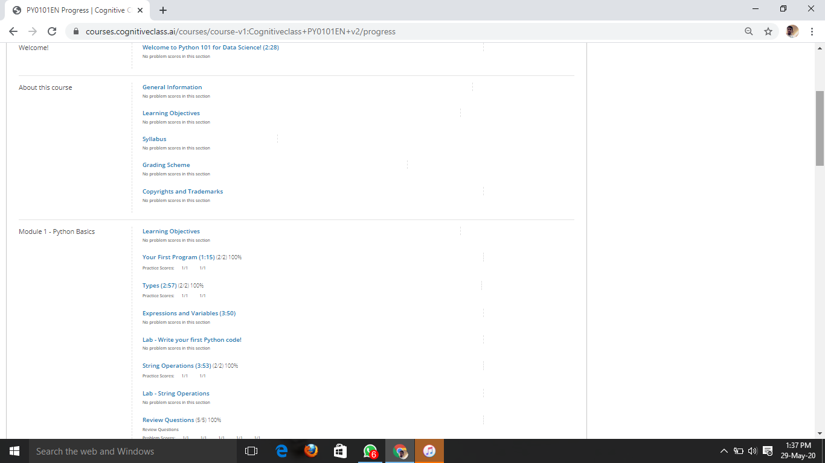

Coding Challenges Details: (Attach the snapshot and briefly write the report for the same)

**PROGRAM 1**

/* Armstrong number is a number that is equal to the sum of cubes of its digits. For example 0, 1, 153, 370, 371 and 407 are the Armstrong numbers.*/

#include <stdio.h>

int main() {

int num, originalNum, rem, result = 0;

printf("Enter a three digit number: ");

scanf("%d", &num);

originalNum = num;

while (originalNum != 0) {

rem = originalNum % 10;

result += rem * rem * rem;

originalNum /= 10;

}

if (result == num)

printf("%d is an Armstrong number.", num);

else

printf("%d is not an Armstrong number.", num);

return 0;

}